# Lab 3: Migrating an Application to AWS

rehost (lift and shift) the application server to an Amazon Elastic Compute Cloud (Amazon EC2) instance.

1. Demonstrate how to migrate a server to Amazon Web Services (AWS) using AWS Application Migration Service.
2. Install and configure a web application server.
3. Install the Application Migration Service on a source machine and configure Application Migration Service for replication.
4. Replicate and migrate a server from on-premises to AWS.

**Task 1: Configure your on-premises application server**

1.1 open and connect to public instance (source) in ec2 -

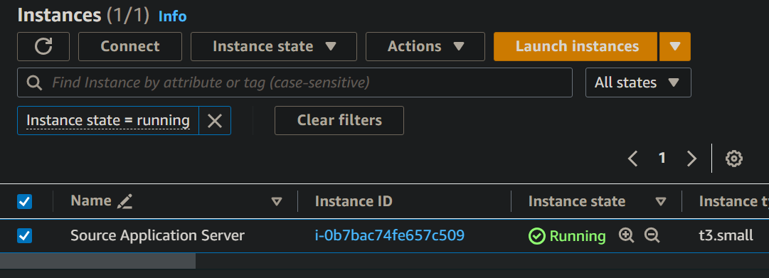

1.2 sample web-app code

*sudo yum update -y &&*

*sudo amazon-linux-extras install -y lamp-mariadb10.2-php7.2 php7.2 &&*

*sudo yum install -y httpd &&*

*sudo systemctl enable httpd.service*

*sudo systemctl start httpd*

*cd /var/www/html*

*sudo wget https://us-west-2-tcprod.s3.amazonaws.com/courses/ILT-TF-200-MTMAWS/v3.4.11.prod-d43d943d/lab-3-migrate/scripts/instanceData.zip*

*sudo unzip instanceData.zip*

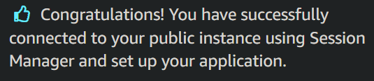

**Task 2: View the source application**

2.1 copy the IP DNS for source server - ec2-18-237-2-167.us-west-2.compute.amazonaws.com

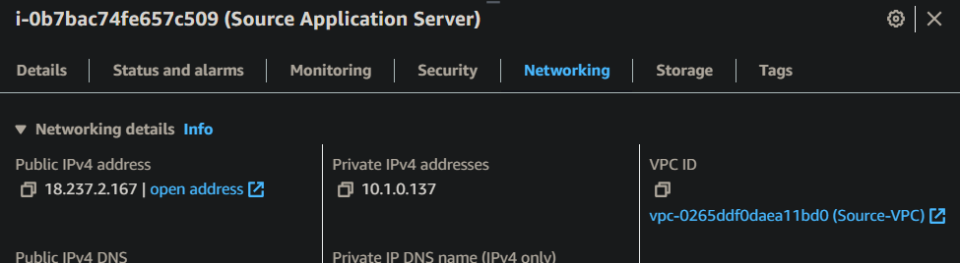

2.2 open the application server - shows AZ ans ID

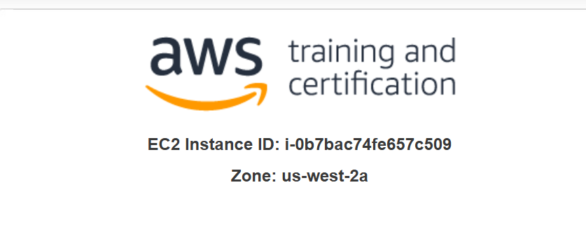

**Task 3: Configure your application migration**

AWS Application Migration Service

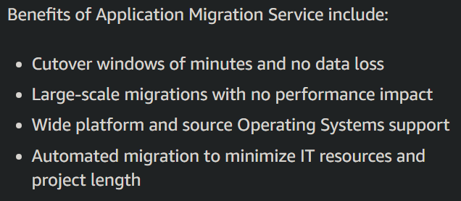

3.1 open AWS Application Migration Service in console

3.2 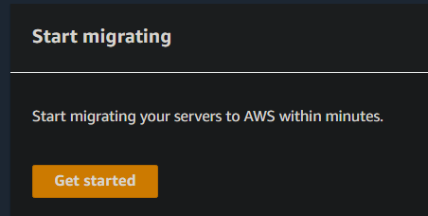

3.3 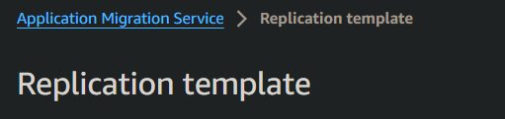

3.4 edit

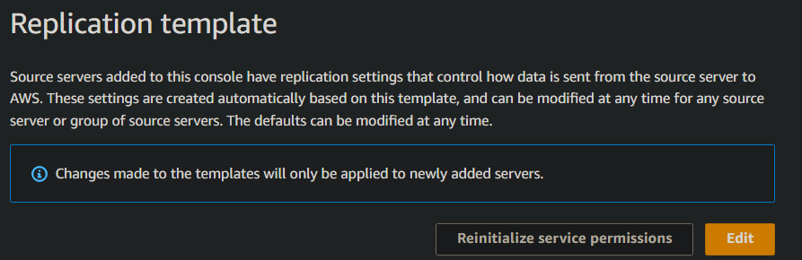

3.5 gpt-**staging area subnet** refers to a specific network segment within an Amazon Virtual Private Cloud (VPC) that is designated for testing and validation purposes during the migration process.

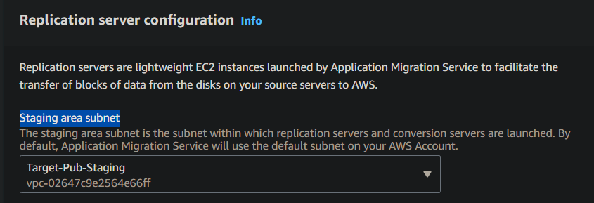

3.6 add source

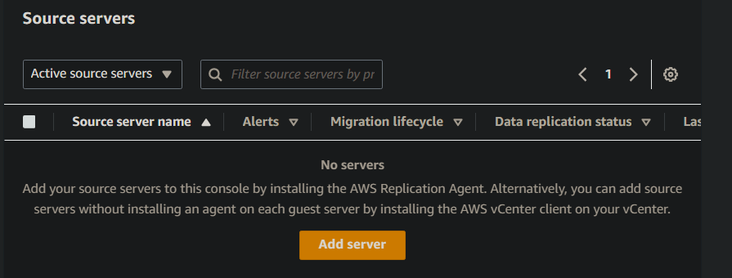

3.7 fill

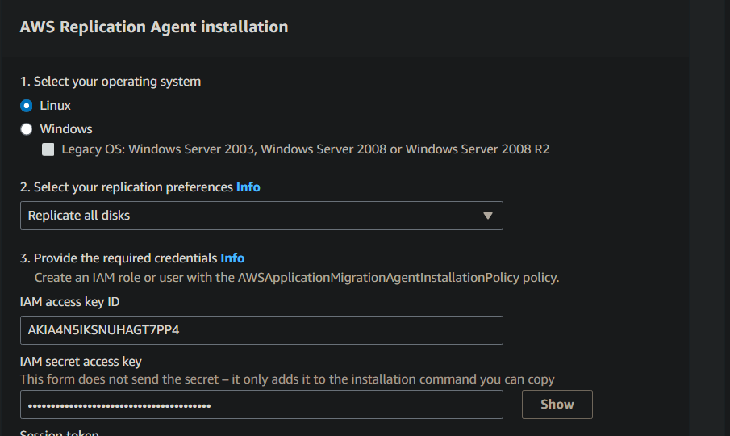

3.8 copy to use when downloading AMS agent on source server

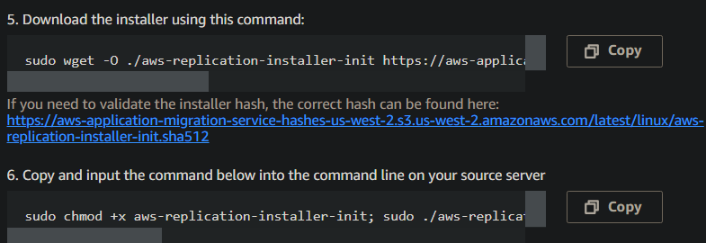

**We used credentials to make scripts that we will use in the source server to download this exact AMS server agent on the source server.**

**Task 4- Install the Application Migration Server agent on your application server**

4.1 connect to source EC2 instance using CLI

4.2 download and install the AMS Replication Agent to your application server. copy commands

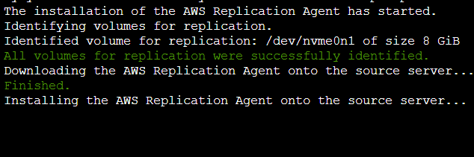

4.3 on the source server

**Task 4: Configure launch settings for the test server**

4.1 go to ams, and select source server

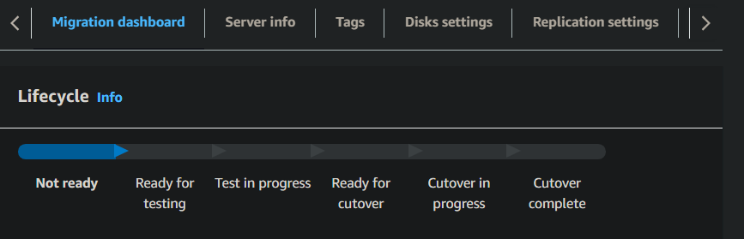

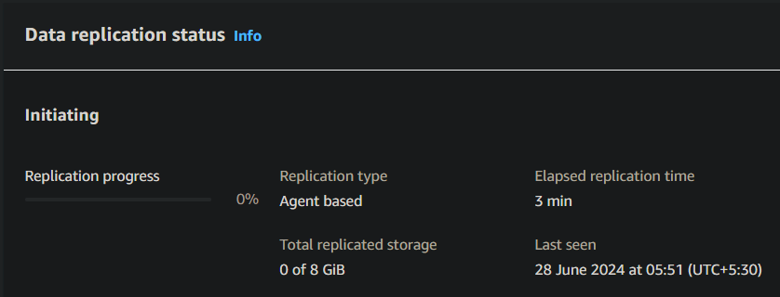

4.2 change EC2 instance type



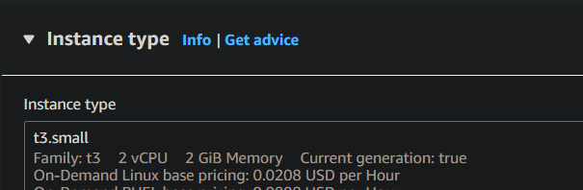

4.3 save the template, view

4.4 set latest template as default

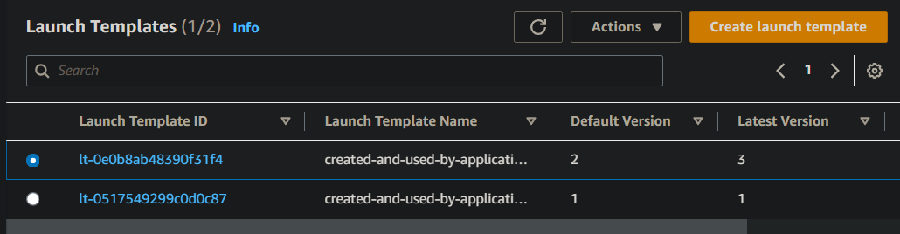

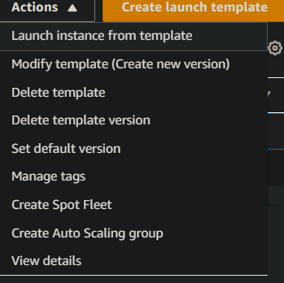

4.5 view the source server

